LCC Shim Lead De-icing
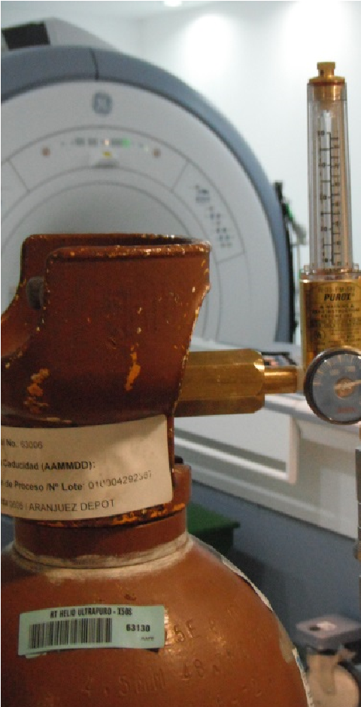
Tools
3ft hose with quick disconnect in one side and nupro valve fitting on the other
20ft hose with quick disconnects in both sides
Flow meter
Shim supply and cables to check continuity
One cylinder of pure He gas

WARNING!! RISK OF QUENCH. DO NOT
ATTEMPT THIS PROCEDURE UNLESS
INSTRUCTEC BY THE MAGNET SERVICE ENGINEERS OR GE MR SPECIALIST.
WARNING!! RISK OF QUENCH IF INCREASING FLOW
OVER 140CFH OR MAGNET PRESSURE NOT KEPT
UNDER 0.5PSI

REQUIRED CONDITIONS:
A minimum helium level of 85% is required prior to start the procedure.
Magnet pressure should be set the week prior between .2 and .4 PSI if possible.

PROCEDURE
- If possible, try to lower pressure in the magnet in advance to 0.4PSI
- Purge flow meter and connect 20ft and purge as well.
- Keep the flow meter vertical to read correctly.
- Set the flow to 140 CFH (REMEMBER IF EXCEEDED THERE IS A HIGH RISK OF QUENCH!). Starting at 80 or 100 CFH and then increasing it is a good practice to make sure the flow is correct. (We start at 60 CFH and work our way up depending on how fast pressure rise.)
- Connect 3ft hose to nupro valve and open valve to purge it and then close it.
- Open V2 to lower the magnet pressure to 0.2 PSI
- Connect the 20ft hose to the 3ft hose.
- Open V2 to avoid the pressure in the magnet to increase rapidly keep open and keep watch
- Leave the nupro valve closed and lower the shim lead until it reaches the top of the ice or the sav-con connector.
- Open nupro valve slowly and leave it open for a maximum of 2-3 minutes without letting the magnet pressure go above 0.5 PSI.
- Keep the V2 closed if you are not attempting to insert the shim lead or you don’t have He gas flowing through the nupro valve.
- Try reseating the shim lead and repeat the process until you achieve good connectivity.

IF UNSUCCESSFUL AFTER SEVERAL ATTEMPTS

Try heating up shim lead with heat gun and lower down with nupro valve open..

